Fact Sheet Beef Safety
Ticks and the Mammalian Meat Allergy
Pia Untalan Olafson, USDA‐Agricultural Research Service; pia.olafson@ars.usda.gov
Tick-borne diseases of humans and livestock are well documented. While sometimes humans who get bitten experience no symptoms, ones who are allergic to tick bites can immediately have a skin reaction of a red or discolored bump on the skin, or the appearance of a rash that gets larger over the course of a few days. In recent history, the novel Heartland and Bourbon viruses were discovered, both of which are transmitted via tick bites and resulted in human illnesses in regions of Missouri, Tennessee, and Kansas.^{[4,6]} Disease is concerning enough, but what if a tick bite could permanently alter your body to make you allergic to red meat and dairy products? This startling possibility has become a reality due to the discovery of how tick bites and specific sugar modifications on red meat combine to create a potentially life-threatening condition receiving increased media attention known as alpha-gal syndrome (AGS), or the mammalian meat allergy^{[10,11]}.
Mammalian meat allergy is a delayed allergic reaction to red meat and some products made from mammals that results from a heightened immune response to a sugar modification, alpha‐galª, present on tissues and meat from non‐primate mammals, e.g. cattle, swine, sheep, deer, rabbits, but not poultry and fish. This sugar is not found in human cells because primates have lost the GGTA1 gene through time and evolution, which used to activate an enzyme responsible for generating this molecule. Therefore, humans have developed antibodies against alpha-gal.^{[8]} While most people can normally digest meat with no issues, for reasons still poorly understood, some people can become sensitized to alpha-gal when certain species of ticks transfer saliva containing the sugar into the body after a bite, initiating an aggressive immune response to alpha-gal and consequently causing an allergy to red meat itself. Tick saliva comprises a cocktail of biomolecules that are secreted into its host upon tick attachment, and these molecules enable the tick to evade the host’s immune system and promote blood‐feeding^{[12]}. Some tick species are known to regurgitate gut contents into the host while feeding, and regurgitation can also occur upon being improperly detached from its host. However, it remains unknown what exactly the tick is transmitting to its human host (via either its salivary secretions or its gut contents) that would stimulate production of IgE antibodies that specifically recognize alpha‐gal. Patients experiencing this allergy report intense itching, swelling, gastrointestinal symptoms (nausea/diarrhea/indigestion), and/or develop hives at 3 – 6 hours after eating red meat, i.e. beef, lamb, pork, venison. The delayed reactions, a unique hallmark of this allergic response, can be severe enough in cases to warrant emergency room visits or hospitalization, and they can occur in individuals who have previously consumed red meat without problems (adult‐onset). This food allergy disorder affects children and adults alike, and it has been reported worldwide. It has been estimated by the CDC that as many as 450,000 Americans have been
ªgalactose-alpha-1-, 3-galactose
diagnosed with alpha-gal syndrome, which would make the allergy the 10th most common food allergy in the US^{[3]}.
The tick that is most understood to be associated with alpha-gal syndrome is Amblyomma americanum, commonly known as the Lone Star tick (Figure 2). Drs. Scott Commins, Thomas Platts‐Mills, and a collaborative team of clinical researchers at the University of Virginia Health System’s Allergy Division, revealed that the delayed red meat allergy was mediated by circulating immunoglobulin E (IgE) antibodies that recognize and bind to alpha‐gal, a signal to the immune system to mount an aggressive response to the ‘foreign’ substance. This connection was based on the overlap between the distribution of the tick and patients with an IgE antibody response to alpha‐gal, and on studies documenting an observable increase in the level of IgE to alpha‐gal after patients experienced a tick bite from the Lone Star tick. This finding resulted from separate studies with cancer patients that exhibited a rapid, allergic reaction upon first infusion with the chemotherapy agent, cetuximab. Cetuximab contains an alpha‐gal region that elicited an allergic reaction (IgE response) in these cancer patients, signifying that they had IgE to alpha‐gal even before receiving cetuximab. Patients describing a delayed red meat allergy were then screened and found to also be positive for IgE to alpha‐gal. The common thread between these patients was their geography ‐ the southeastern United States. A higher prevalence of IgE to alpha‐gal has been seen in this region compared with four other regions across the US^{[1]} (Figure 1), indicating that eating food containing alpha‐gal (mammalian meat or their by‐products) does not itself prime the immune system to produce IgE to the carbohydrate. Rather, Drs. Commins and Platts‐Mills proposed that the Lone Star tick had an important role in mammalian meat allergy in the US.
Lone Star ticks live across the southeastern, midwestern, and eastern United States, although recent reports indicate populations are being reported as far west as Nebraska and South Dakota due to expansion of their tolerable habitat range largely due to the effects of climate change^{[9]}. Females are easily identified by a white spot on their backs. They are most often found in wooded areas with thick underbrush, and along the edges of meadows and streams. The American dog tick, Dermacentor variabilis, is also prevalent in this region, but its bites do not appear to induce elevated production of IgE to alpha‐gal, further supporting the importance of the Lone Star tick. Tick bites from the Australian paralysis tick, Ixodes holocyclus, and the castor bean tick, Ixodes ricinus, are also associated with a delayed red meat allergy in Australia and Europe, respectively, and there are now cases reported in Asia, Africa and Central America, although the responsible tick species in these continents is still unclear. The development of alpha-gal syndrome can take anywhere from 1-3 months, and the duration of the syndrome varies; the rate of decline in sensitivity is variable and can take months, years, or, in some cases, persist throughout a lifetime^{[5]}. No treatment for this affliction currently exists; avoidance of meat and dairy products is the only recommended intervention, with gradual reintroduction of small servings of dairy/lean meat products to see if they are well tolerated. Some afflicted people might even need to take steps such as watching out for cross-contamination of
meat from other surfaces, such as at a restaurant where they might cook chicken and beef products on the same grill. Avoidance of further tick bites is also required, since most patients who successfully avoid bites will experience a decrease in alpha-gal IgE levels.
Physicians and allergists are becoming more aware of the tick‐induced delayed allergy to red meat, and a laboratory diagnostic test is now available to screen patients for the presence of IgE to alpha‐gal. However, data retrieved from a recent CDC report showed that nearly 42% of 1,500 survey respondents of physicians had not heard of AGS and 35% were “not too confident” about their ability to diagnose or manage patients with AGS^{[2]}. Therefore, people who think they might be afflicted should be proactive and ask about the possibility that they are affected to their physician and ask for a screening test. The CDC^{[7]} recommends measures be taken before and after spending time in areas known to be tick‐infested, e.g. brushland, wooded areas, etc. These include the application of repellents containing 20 – 30% DEET to exposed skin and clothing as instructed on the product label, the treatment of clothing and gear (boots, hats) with products containing 0.5% permethrin, and conducting a full‐body tick check after working in tick‐ infested areas in order to locate and properly remove attached ticks of various life stages (Figure 2). For more information regarding tick identification and tick bite prevention and removal, please visit the resources available at the CDC (https://www.cdc.gov/ticks/) and TickEncounter (https://tickencounter.org/) websites.
Original content was provided by Pia Untalan Olafson with the USDA‐Agricultural Research Service; pia.olafson@ars.usda.gov. This current version has been updated for 2023.

1. Altrich, M. L., S. P. Blum, and S. M. Foster. 2015. Alpha-gal IgE sensitization in the United States; Surveillance Update. Journal of Allergy and Clinical Immunology 135.
2. Carpenter, A., N. A. Drexler, D. W. McCormick, J. M. Thompson, G. Kersh, S. P. Commins, and J. S. Salzer. 2023. Health Care Provider Knowledge regarding alpha-gal syndrome – United States, March-May 2022. MMWR. Morbidity and Mortality Weekly Report 72:809-814.
3. Emerging tick bite-associated meat allergy potentially affects thousands. 2023. Centers for Disease Control and Prevention. Available from: https://www.cdc.gov/media/releases/2023/p0727-emerging-tick-bites.html
4. Kosoy, O.I., A. J. Lambert, D. J. Hawkinson, D. M. Pastula, C. S. Goldsmith, D. C. Hunt, and J. E. Staples. 2015. Novel thogotovirus associated with febrile illness and seath. United States, 2014. Emerging Infectious Diseases 21.
5. Lee, C. J., and S. K. McGill. 2023. Food allergies and alpha-gal syndrome for the gastroenterologist. Current Gastroenterology Reports 25:21-30.
6. Pastula, D. M., G. Turabelidze, K. F. Yates, T. F. Jones, A. J. Lambert, A. J. Panella, O. I. Kosoy, J.
O. Velez, M. Fisher, and J. E. Staples. 2014. Notes from the field: Heartland virus disease – United States, 2012-2013. Centers for Disease Control and Prevention. Available from: https://www.cdc.gov/mmwr/preview/mmwrhtml/mm6312a4.htm
7. Preventing tick bites. 2020. Centers for Disease Control and Prevention. Available from: https://www.cdc.gov/ticks/avoid/on_people.html
8. Sharma, S. R., and S. Karim. 2021. Tick saliva and the alpha-gal syndrome: Finding a needle in a Haystack. Frontiers in Cellular and Infection Microbiology 11.
9. Sonenshine, D. 2018. Range expansion of tick disease vectors in North America: Implications for spread of tick-borne disease. International Journal of Environmental Research and Public Health 15:478.
10. Steinke, J. W., T. A. E. Platts-Mills, and S. P. Commins. 2015. The alpha-gal story: Lessons learned from connecting the dots. Journal of Allergy and Clinical Immunology 135:589-596.
11. Van Nunen, S. 2015. Tick-induced allergies: Mammalian meat allergy, tick anaphylaxis and their significance. Asia Pacific Allergy 5:3-16.
12. Wikel, S. 2013. Ticks and tick-borne pathogens at the cutaneous interface: Host defenses, Tick Countermeasures, and a suitable environment for Pathogen Establishment. Frontiers in Microbiology 4.

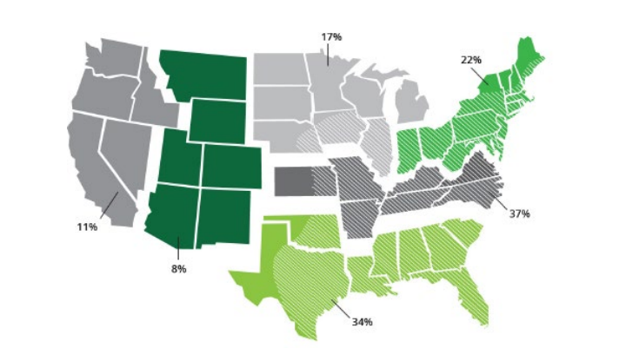
Figure 1. Surveillance for IgE to alpha‐gal. Percent positive rates are presented for IgE to alpha‐gal within each of six regions in the United States, 2012‐2013 (7300 samples). Diagonal white lines on the map represent the known geographic distribution of the Lone Star tick (Data and map, Viracor‐ IBT Laboratories; Tick distribution, CDC).

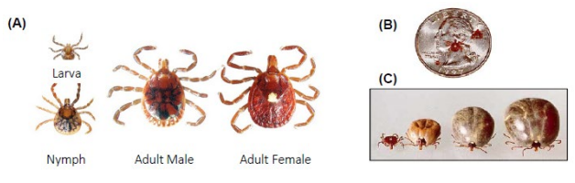
Figure 2. (A) Lone Star tick life stages. The iridescent, solitary white spot on its dorsal surface is a marking that distinguishes adult, female Lone Star ticks from other tick species. Representative images of larval, nymphal and adult male Lone Star ticks are also presented. Photo, URI TickEncounter Resource Center, with permission. (B) Size comparison of Lone Star tick life stages. A nymph, unfed adult female and unfed adult male tick are shown relative to a quarter (from left to right). Photo, SCS, Ltd., tickinfo.com, with permission. (C) Unfed, partially fed and engorged female Lone Star ticks are shown. Note that the solitary white spot remains visible. Photo, SCS, Ltd., tickinfo.com, with permission.

